Connecting to the Database

Linking to the Database 1
Creating your Database 1
Creating Tables 6
Adding Data 10
Creating Stored Procedures 14
Testing the Stored Procedure 16

Linking to the Database
The code we have in our constructor is ok for test purposes however so far as the finished system goes it is a bit rubbish.
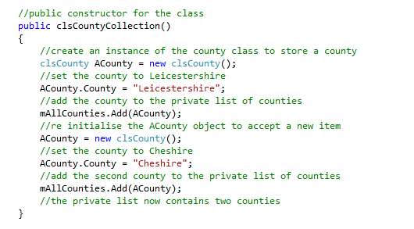
There are far more counties in the UK rather than just two. (Depending on the status of Rutland there is a fairly static amount.)
The next step is to make the leap to connecting to the database.
In this work we will go through the process of setting up an account on Microsoft Azure and look at the different options we have for managing the database.

Creating your Database
In this example we will set up a local database for the system we will create.
The first question is where to store the database?
If we create the database within any one of the projects in our system it will only be available to that project and not the others.
For example we could set up the database within the web front end but then the class library would be unable to access the data.
To get round this we need to create the database within the root folder of the solution.
If you open the folder structure of the system you should see the following…
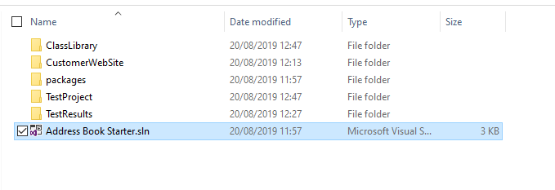
Right click and create a new App_Data folder at this level of the solution, i.e. not in one specific project.
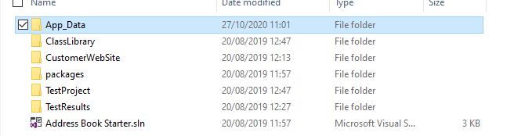
Now from within Visual Studio access the server explorer to the left of the interface…
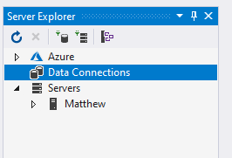
Create a new database by clicking the following icon…
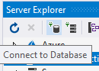
This will take you to the following screen…
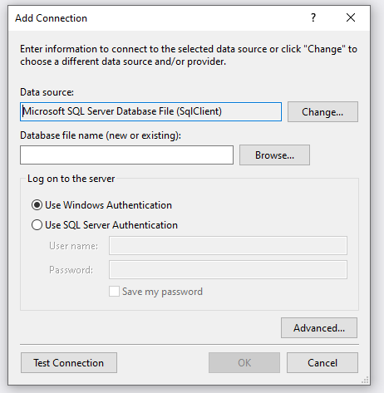
Press browse and navigate to the App_Data folder you just created…
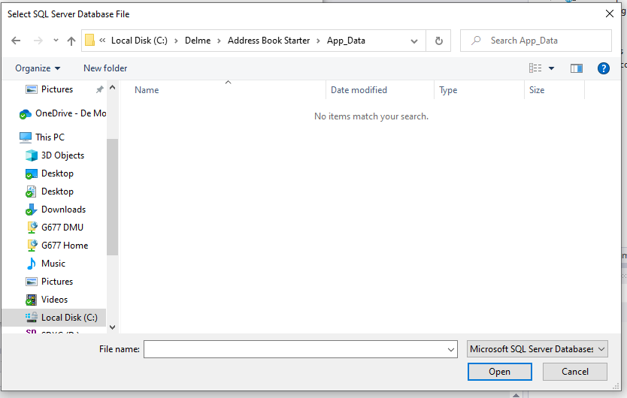
Enter a name for the database file you want to create and press open…
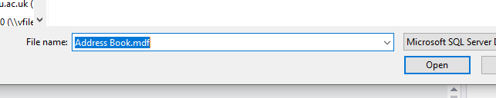
Next press OK…
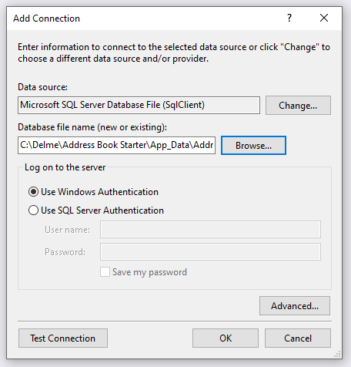
Press yes when asked to create the database…
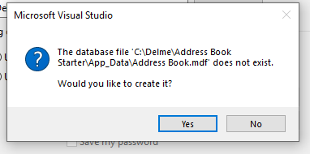
You should now see the database available in the server explorer…
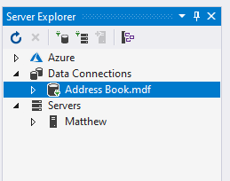

Creating Tables
The next resource we need to create is a table to store some data in.
From the server explorer, right click on the section marked tables selecting “Add New Table”...
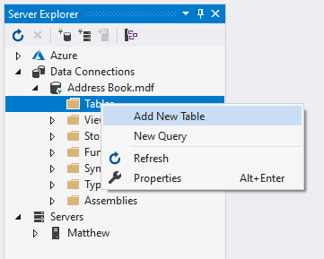
After a bit of waiting you will be presented with the following screen...
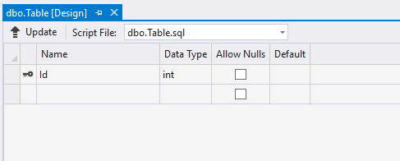
We will set up a basic table to store our list of counties.
First, set the name of the table by modifying the SQL at the bottom of the window setting the table name to tblCounty...
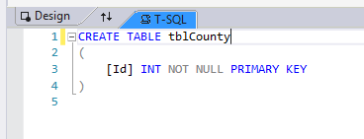
(“tbl” is just a naming table to remind us that this is a table!)
Next we will add the primary key. In the top window set up the first field like so...
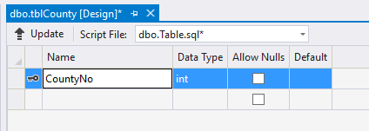
Next we need to set up the primary key so that it automatically increments every time we add a new record. To do this we need to set identity to true.
With the field still selected (in blue) access the properties for the field in the bottom right of the interface, switch “Is Identity” from false to true...
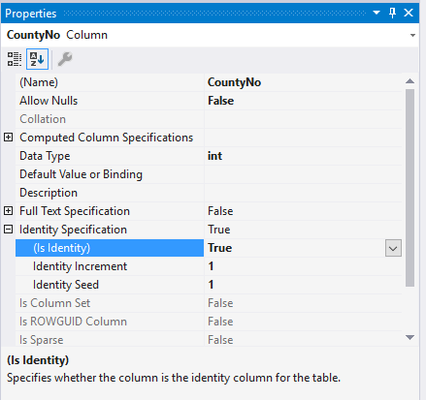
Lastly create the second attribute County like so...
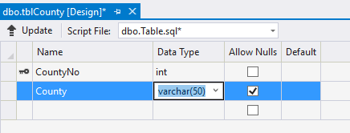
Watch out for nchar! If you want to store text based data varchar is a much better choice than nchar. Nchar produces fixed length strings that don’t always behave how you might expect.
To create the table you must press the button “Update”, if you don’t then the structure of the database will not be changed.
When you press update you will be presented with an preview screen like so...
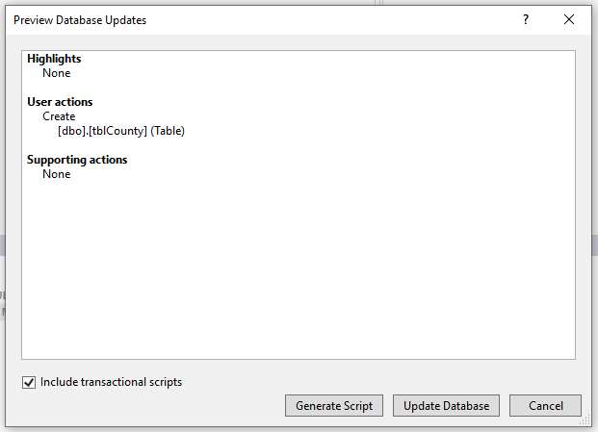
Assuming there are no errors press “Update Database”. You are looking for a green dot appearing once the table is created...
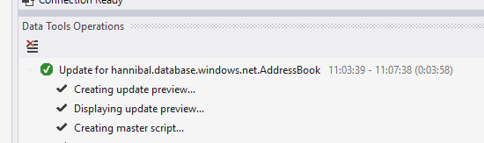
(It may take a while!)
Your table should now be visible, if not right click on the tables branch and select refresh.
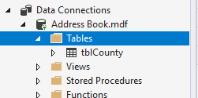

Adding Data
Now that we have created the structure of the table we need to add some data to the table.
To do this right click on the table and Show Table Data...
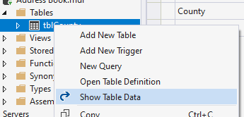
Rather than sitting typing all of these counties into the table I would suggest copying and pasting the records directly into the table.
1 | Avon
2 | Bedfordshire
3 | Berkshire
4 | Buckinghamshire
5 | Cambridgeshire
6 | Cambridgeshire and Isle of Ely
7 | Cheshire
8 | City of Bristol
9 | City of London
10 | Cleveland
11 | Cornwall
12 | Cumberland
13 | Cumbria
14 | Derbyshire
15 | Devon
16 | Dorset
17 | Durham
18 | East Suffolk
19 | East Sussex
20 | Essex
21 | Gloucestershire
22 | Greater London
23 | Greater Manchester
24 | Hampshire (County of Southampton)
25 | Hereford and Worcester
26 | Herefordshire
27 | Hertfordshire
28 | Humberside
29 | Huntingdon and Peterborough
30 | Huntingdonshire
31 | Isle of Ely
32 | Isle of Wight
33 | Kent
34 | Lancashire
35 | Leicestershire
36 | Lincolnshire
37 | Lincolnshire, Parts of Holland
38 | Lincolnshire, Parts of Kesteven
39 | Lincolnshire, Parts of Lindsey
40 | London
41 | Merseyside
42 | Middlesex
43 | Norfolk
44 | North Humberside
45 | North Yorkshire
46 | Northamptonshire
47 | Northumberland
48 | Nottinghamshire
49 | Oxfordshire
50 | Rutland
51 | Shropshire (Salop)
52 | Soke of Peterborough
53 | Somerset
54 | South Humberside
55 | South Yorkshire
56 | Staffordshire
57 | Suffolk
58 | Surrey
59 | Sussex
60 | Tyne and Wear
61 | Warwickshire
62 | West Midlands
63 | West Suffolk
64 | West Sussex
65 | West Yorkshire
66 | Westmorland
67 | Wiltshire
68 | Worcestershire
69 | Yorkshire
70 | Yorkshire, East Riding
71 | Yorkshire, North Riding
72 | Yorkshire, West Riding

You should end up here...
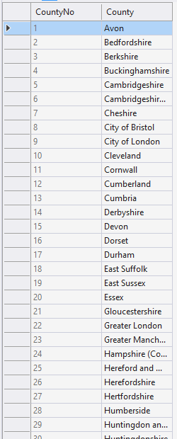
Close the table once the data has been pasted.

Creating Stored Procedures
As mentioned above we will not be accessing the table directly with our code but using a stored procedure. One of the biggest advantages of this approach is that of increased security.
Creating a stored procedure is a very similar process to creating a table.
In the SQL Object Browser right click on the stored procedure branch and select “Add New Stored Procedure...”
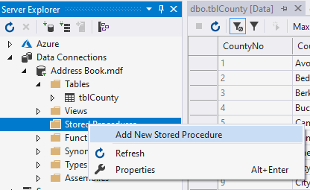
After a little while you should see the following screen appear...
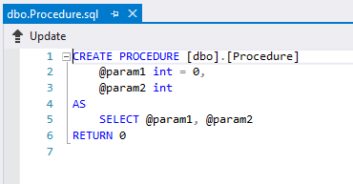
Modify the SQL code as follows...
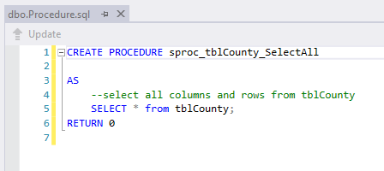
As in the case of a table you must press update to make the changes to the database structure.
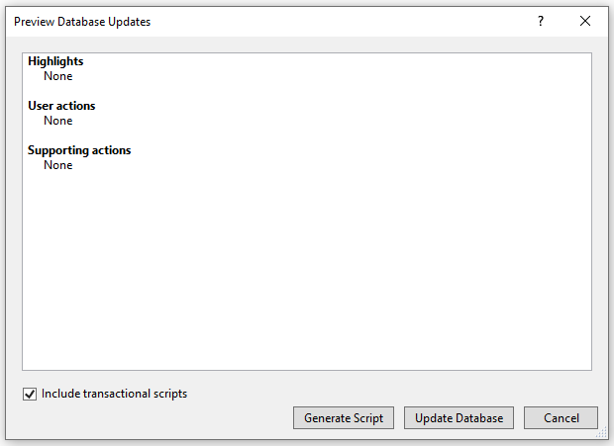
You should see the stored procedure in the tree structure of the database, if not try refreshing it...
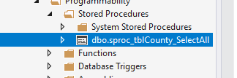

Testing the Stored Procedure
To make sure the stored procedure is working right click on it like so...
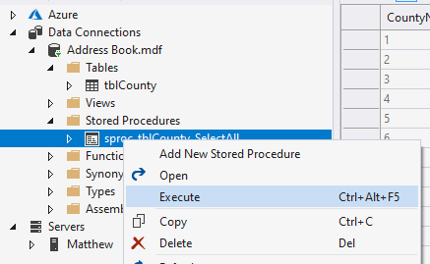
You should see the data from the underlying table displayed...
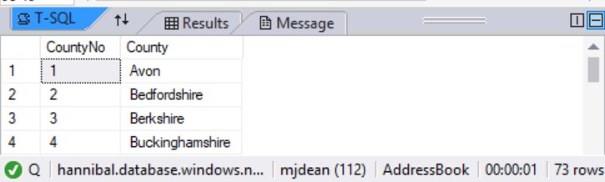
Close the query output window, don’t bother saving it.
We are now at the stage where we are able to complete the collection class and link the code to the database.

